PROJECT REPORT

**DATA COMMUNICATION AND NETWORKING**

**CSC410**



**ABC University**

**Hamza Majid (20181-24736)**

**Nafia Mehmood (20181-24712)**

**Abdul Saboor (20181-24810)**

DEPARTMENT OF COMPUTER SCIENCE

COLLEGE OF COMPUTER SCIENCE & INFORMATION SYSTEM

INSTITUTE OF BUSINESS MANAGEMENT, KARACHI

SPRING 2020

ABC University Project

BY

**Std_24736@iobm.edu.pk**

**Std_24810@iobm.edu.pk**

**Std_24712@iobm.edu.pk**

DATA COMMUNICATION AND NETWORKING

DEPARTMENT OF COMPUTER SCIENCE

COLLEGE OF COMPUTER SCIENCE & INFORMATION SYSTEM

INSTITUTE OF BUSINESS MANAGEMENT, KARACHI

SPRING 2020

**SUPERVISED BY**

**LECTURER,**

**Mrs. Saadia Karim**

DEPARTMENT OF COMPUTER SCIENCE

COLLEGE OF COMPUTER SCIENCE & INFORMATION SYSTEM

INSTITUTE OF BUSINESS MANAGEMENT, KARACHI

**A Report submitted in partial fulfillment of the requirements for the course of CSC213**

**COLLEGE OF COMPUTER SCIENCE & INFORMATION SYSTEM**

**INSTITUTE OF BUSINESS MANAGEMENT, KARACHI**

**SPRING 2020**

**Table of Content**

|  |  |  |
| --- | --- | --- |
| **S.no** | **Description** | **Page no.** |
| 1 | Table for figures | ii |
| 2 | Acknowledgement | iii |
| 3 | Abstract | 1 |
| 4 | Introduction | 2 |
| 5 | Description | 3 |
| 6 | Conclusion | 7 |
| 7 | References | 8 |

**Table for Figures**

|  |  |  |
| --- | --- | --- |
| **Figures** | **Description** | **Page#** |
| 1 | NETWORK STRUCTURE | 3 |
| 2 | PROJECT INTRODUCTION | 4 |
| 3 | PROJECT DETAIL | 5 |

**ACKNOWLEDGEMENT**

I would like to thank my course & project supervisor, Mrs. Saadia Karim, for providing an awful amount of guidance and input throughout the writing of this report. In addition, I’d like to thank my family for the support, and for checking over my report.

**ABSTRACT**

Cisco system are basically networking device manufacturer and education proving mediums teaching student how to work with the networks. In order to help their students to understand the network or how devices work in network, they created cisco packet tracker. As the name suggest this virtually shows that how devices are connected to one another and how data travels between them. Cisco packet tracer have almost every networking devices to cables, where one can place them in any desired layout and connect each other using same type old devices and cables we have in the market. In other words, cisco packet tracer is a software who is used to help in practical’s and take test of -cisco certification student whereas companies can benefit from it by simulating any changes in their network if the simulation is successful then companies may implement them in real life.

This report was written by Hamza Majid, Nafia Mehmood &Abdul Saboor as part of his DATA COMMUNICATION AND NETWORKING course project for Spring 2020. This report is publish on 07 May 2020

**INTRODUCTION**

Packet Tracer is a versatile network simulator that can be used in network qualification training by allowing students to build networks with a virtually infinite number of devices and experience troubleshooting without going through actual Cisco routers or switches.

Cisco packet tracer works basic-ally on two functionality or the main two features are:-

The logical workspace allows users of to virtually connect network tools to construct conceptual network topologies and clustering virtual network devices just like that. The physical workspace provides the logical network with a graphical physical aspect, providing a sense of scale and positioning of how network devices like routers, switches, and hosts will appear in a real world. The physical view also includes the spatial depictions of multi-city networks, houses and wiring cabinets.

As there are two modes in CISCO packet tracer where in real time the network and simulation would act like the Real time network devices would work then comes virtual time where time or duration is the hand of the user. But mainly for cisco certifications real time is used as it would tell and gives the feeling to student like they are working on real devices.

**DESCRIPTION**

**Network Structure**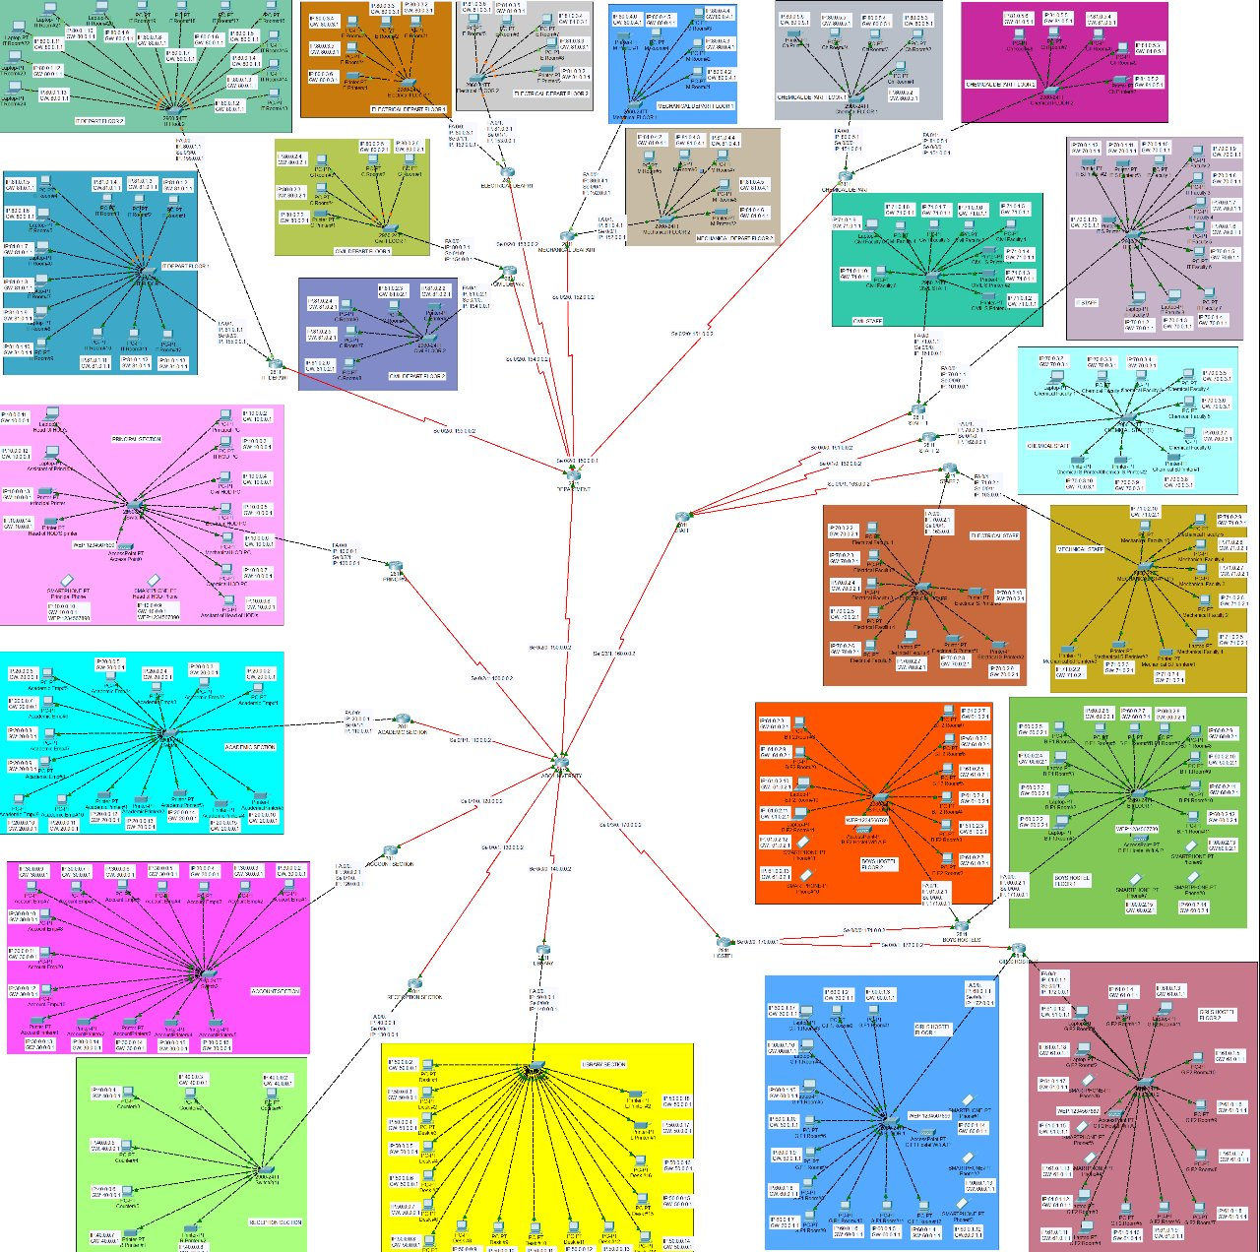

**Project Introduction**

We have created a ABC university structure underlying and keeping their main departments in our mind and then respective departments needs as well. The network topology followed here is hybrid as two topologies are combined here where router connect the departments with one another is mesh topology and topology of network with department is Star topology. The above image is networking image of ABC University which contain multiple different kind of department in it, the list of department are:

* Principle Section
* Academic Section
* Accounts Section
* Reception Section
* Library Section
* Hostels
  + Girls Hostel
  + Boys Hostel
* Staff Section
* Departments Section
  + IT Depart
  + Civil Depart
  + Electrical Depart
  + Mechanical Depart
  + Chemical Depart

We will evaluate each department for further evaluation and we will see how each department lock like.

**Project Details**

Department’s unique IP address is **100.0.0.1**

**Principle Section**

Principle department is one of the most important of the University because it should have to be connected to all the other section of the university. The main reason for this connection is because it the main section which control all the academic of the university and every teacher, staff member and students should have to be connected which the head of the each department. This depart contain 7 computers and two laptop and 2 printer with the switch and this depart has one access point which can give access for about 24 devices at a time.

Department’s unique IP address is **110.0.0.1**

**Academic Section**

Academic section is the heart of all the university academic process because it plays the role of father/mother for any university. It duty is to check and across check all the work. Make the course outline and see that weather the teacher are providing quality education. In this section we can also have some HODs of the department.

Department’s unique IP address is **120.0.0.1**

**Accounts Section**

This is also one the most important section for any organization because it contain all the financial documents. This depart is most important and it should get more importance in the organization and the printing work of this depart is more as compare to other departments. So for this reason it has 5 printers and 11 computers in this section.

Department’s unique IP address is **130.0.0.1**

**Reception Section**

This is also an important department because if any student has any query instead of contacting directly to the principle depart the student or the staff member can get the clarification. This department can also handle a more issues. This department contain 6 computers and 1 printer.

Department’s unique IP address is **140.0.0.1**

**Library Section**

Library has its own importance it the university, as it the main hub for providing all the book and general, it can provide you all the research paper for any topic at any time.

Department’s unique IP address is **150.0.0.1**

**Department Section**

This department have different subsection of departments

1. IT Section

Department’s unique IP address is **155.0.0.1**

This department is divided into two floors but is uses one router. It depart has 8 laptops, 16 Computer.

1. Civil Section

Department’s unique IP address is **154.0.0.1**

This department is divided into two floors but is uses one router. It depart has 8 Computer and 2 printers.

1. Electrical Section

Department’s unique IP address is **153.0.0.1**

This department is divided into two floors but is uses one router. It depart has 8 Computer and 2 printers.

1. Mechanical Section

Department’s unique IP address is **152.0.0.1**

This department is divided into two floors but is uses one router. It depart has 8 Computer and 2 printers.

1. Civil Section

Department’s unique IP address is **151.0.0.1**

This department is divided into two floors but is uses one router. It depart has 8 Computer and 2 printers.

Department’s unique IP address is **160.0.0.1**

**Staff Section**

As every section has its own importance this section also have its own importance because it has all the offices of the faculty of each department. As there are 4 different depart so this build has three floors it in connected with one router divided into three section for each floor. His department have 26 computers, 6 laptops, and 9 printers.

Department’s unique IP address is **170.0.0.1**

**Hostel Section**

This department have different subsection of departments

1. Boys Hostel

Department’s unique IP address is **171.0.0.1**

This department is divided into two floors but is uses one router. It depart has 5 laptops, 16 Computer and 5 smartphone.

1. Girls Hostel

Department’s unique IP address is **172.0.0.1**

This department is divided into two floors but is uses one router. It depart has 16 Computer, 8 Laptops and 6 smartphone

**CONCLUSION**

The above network structure is just an example of how networks in an organization and this is clearly a virtualization of real life network structure of an ABC university, we included few departments to keep things normal for our brains and software as well, Still we tried our best to innovate and try something new in this project that is by the means of making a network whose getting down rate and redundancy rate is reduced as much as possible. We used hash topology to connect different departments and within department topology varies from star topology to hybrid topology i.e. mixture of both star and tree topology.

**REFERENCES**

[1] <https://www.edcast.org/learn/introduction-to-cisco-packet-tracer-network-simulator-open>

[2] <https://www.racksolutions.com/news/blog/server-room-explained/>